PDC LAB 11
Advait Deochakke
20BCE1143

1. Broadcast

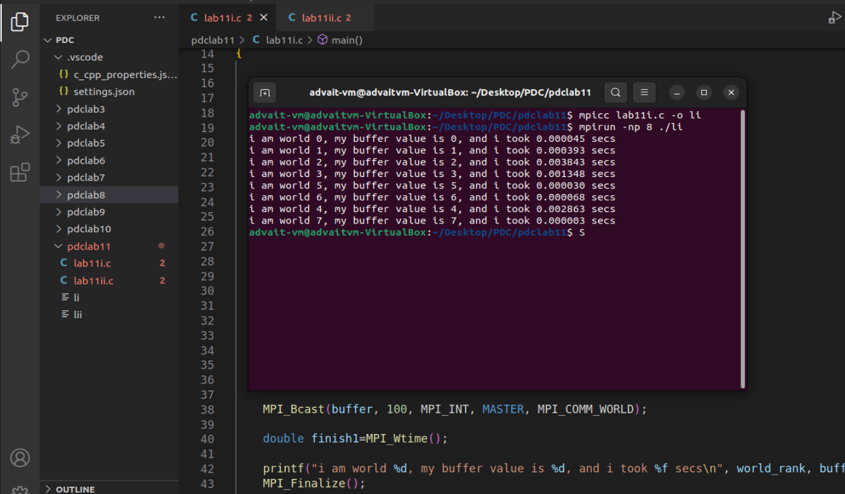

Code:

#include<mpi.h>
#include<stdio.h>
#include<stdlib.h>
#include<time.h>
#include<stdbool.h>
#include<unistd.h>

#define MASTER 0
#define FROM_MASTER 1
#define FROM_WORKER 2

int main()
{

MPI_Status status;
MPI_Request request = MPI_REQUEST_NULL;

MPI_Init(NULL, NULL);

int world_size;
MPI_Comm_size(MPI_COMM_WORLD, &world_size);

int world_rank;
MPI_Comm_rank(MPI_COMM_WORLD, &world_rank);

double start = MPI_Wtime();

int msg_tag=1729;
int buffer[100]={0};
if(world_rank==MASTER)
{
for(int i=0; i<100; i++)
buffer[i]=i;
}
double start1=MPI_Wtime();

MPI_Bcast(buffer, 100, MPI_INT, MASTER, MPI_COMM_WORLD);

double finish1=MPI_Wtime();

printf("i am world %d, my buffer value is %d, and i took %f secs\n", world_rank, buffer[world_rank], finish1-start1);
MPI_Finalize();

return 0;

}

<next Page>

2. Scatter – Example
3. Scatter – Random Numbers
4. Gather
5. Barrier

(Combined into One code to show functionality of each)
(Barrier makes sure that printf order is consistent 01234567)

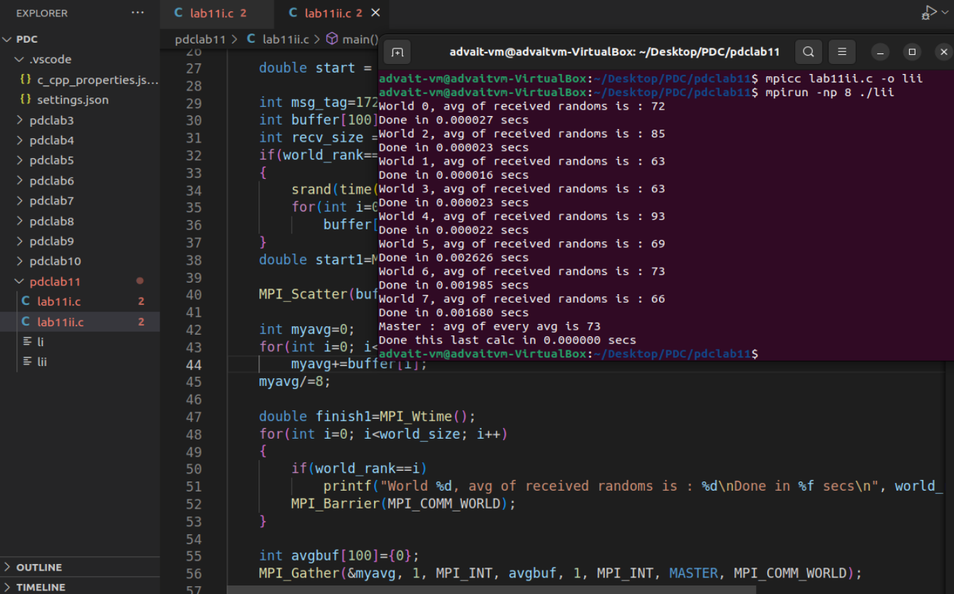

Code :

#include<mpi.h>
#include<stdio.h>
#include<stdlib.h>
#include<time.h>
#include<stdbool.h>
#include<unistd.h>

#define MASTER 0
#define FROM_MASTER 1
#define FROM_WORKER 2

int main()
{

MPI_Status status;
MPI_Request request = MPI_REQUEST_NULL;

MPI_Init(NULL, NULL);

int world_size;
MPI_Comm_size(MPI_COMM_WORLD, &world_size);

int world_rank;
MPI_Comm_rank(MPI_COMM_WORLD, &world_rank);

double start = MPI_Wtime();

int msg_tag=1729;
int buffer[100]={0};
int recv_size = 100/world_size;
if(world_rank==MASTER)
{
srand(time(NULL));
for(int i=0; i<world_size*recv_size; i++)
buffer[i]=rand()%100;
}
double start1=MPI_Wtime();

MPI_Scatter(buffer, recv_size, MPI_INT, buffer, recv_size, MPI_INT, MASTER, MPI_COMM_WORLD);

int myavg=0;
for(int i=0; i<recv_size; i++)
myavg+=buffer[i];
myavg/=8;

double finish1=MPI_Wtime();
for(int i=0; i<world_size; i++)
{
if(world_rank==i)
printf("World %d, avg of received randoms is : %d\nDone in %f secs\n", world_rank, myavg, finish1-start1);
MPI_Barrier(MPI_COMM_WORLD);
}

int avgbuf[100]={0};
MPI_Gather(&myavg, 1, MPI_INT, avgbuf, 1, MPI_INT, MASTER, MPI_COMM_WORLD);

if(world_rank==MASTER)
{
double start=MPI_Wtime();
int fullavg=0;
for(int i=0; i<world_size; i++)
fullavg+=avgbuf[i];
fullavg/=world_size;
double finish=MPI_Wtime();
printf("Master : avg of every avg is %d\nDone this last calc in %f secs\n", fullavg, finish -start);
}

MPI_Finalize();

return 0;

}

------------------------------------------------------------------------------------------------------------------------

